**Name: Yash Laxman Gawade**

**Roll No.: 21140 Subject: CL-3**

**Class: BE (A) Branch: AI&DS**

**Assignment No.: 01**

**Output:**

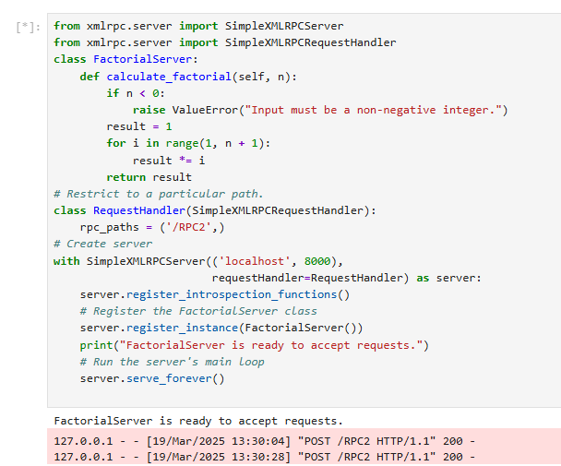

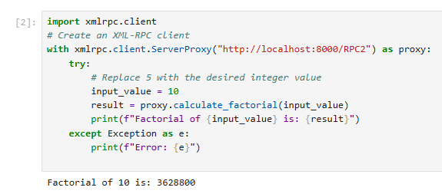

**Name: Yash Laxman Gawade**

**Roll No.: 21140 Subject: CL-3**

**Class: BE (A) Branch: AI&DS**

**Assignment No.: 02**

**Output:**

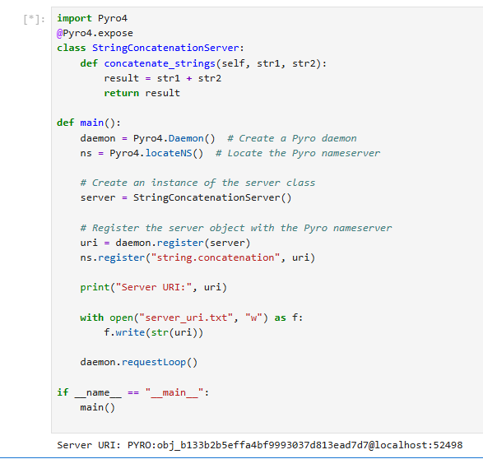

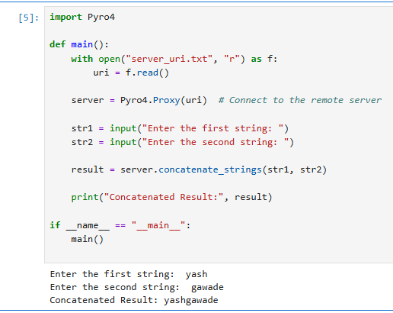

**Name: Yash Laxman Gawade**

**Roll No.: 21140 Subject: CL-3**

**Class: BE (A) Branch: AI&DS**

**Assignment No.: 03**

**Output:**

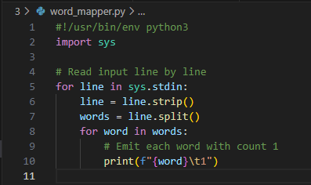

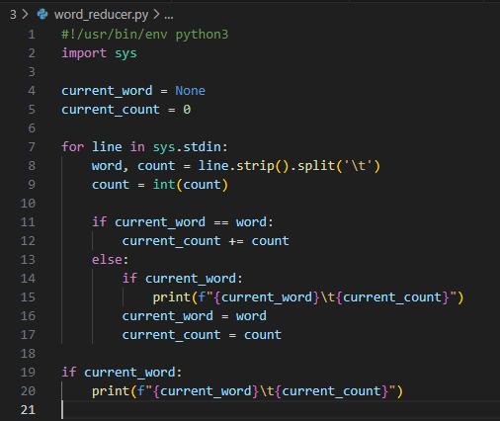

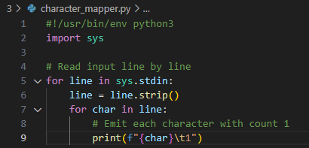

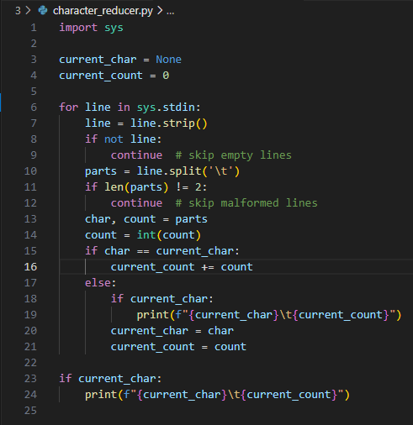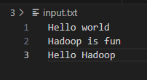 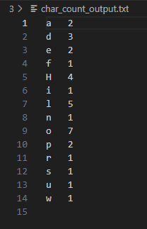



**Name: Yash Laxman Gawade**

**Roll No.: 21140 Subject: CL-4**

**Class: BE (A) Branch: AI&DS**

**Assignment No.: 01**

**Output:**

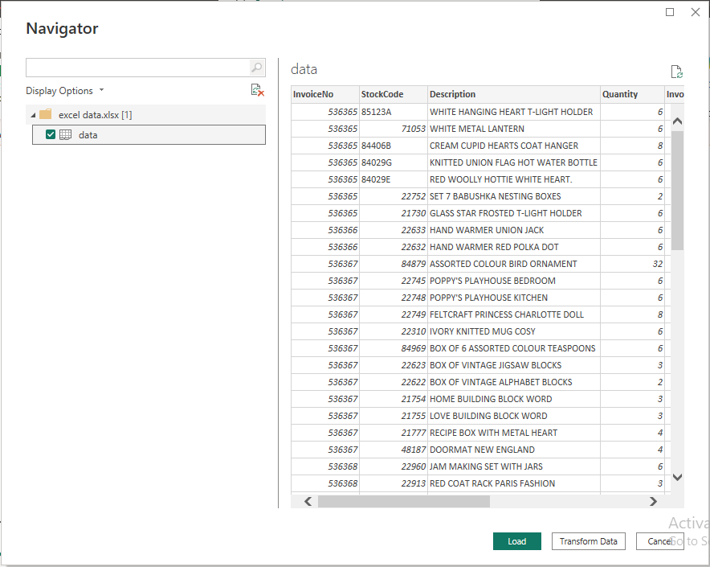

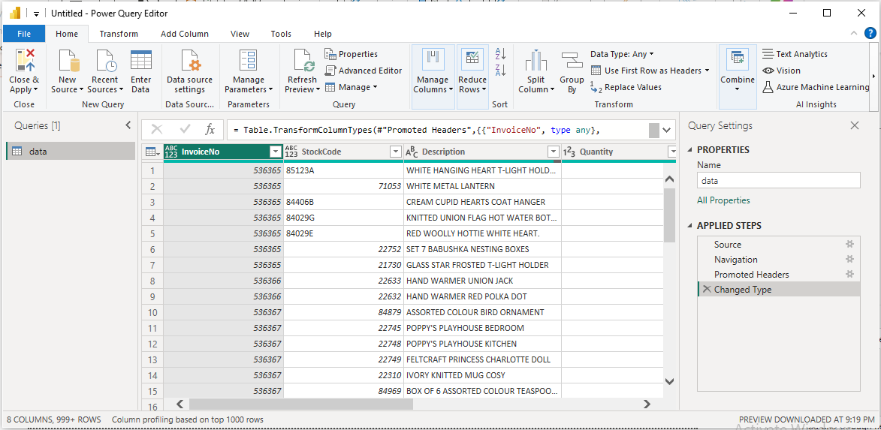

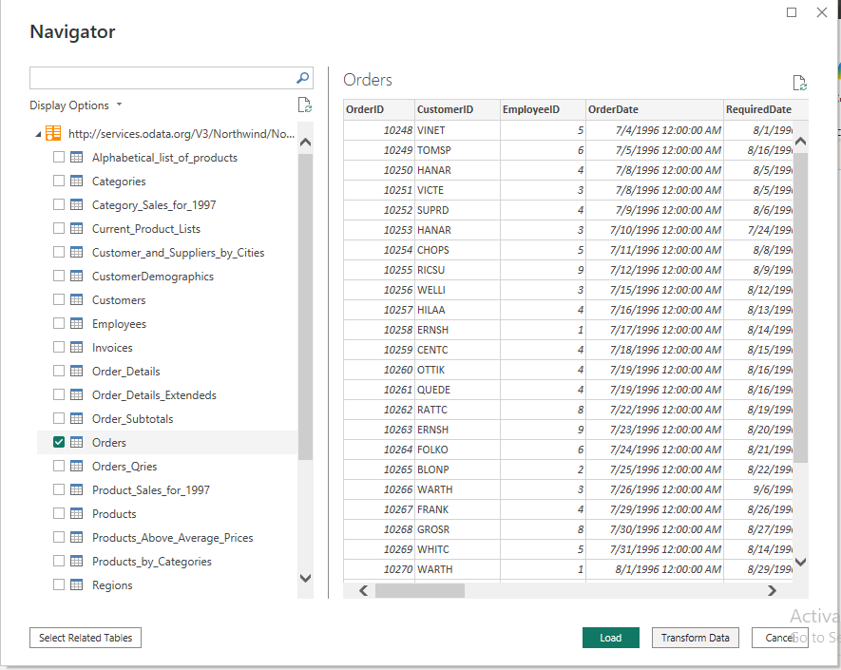

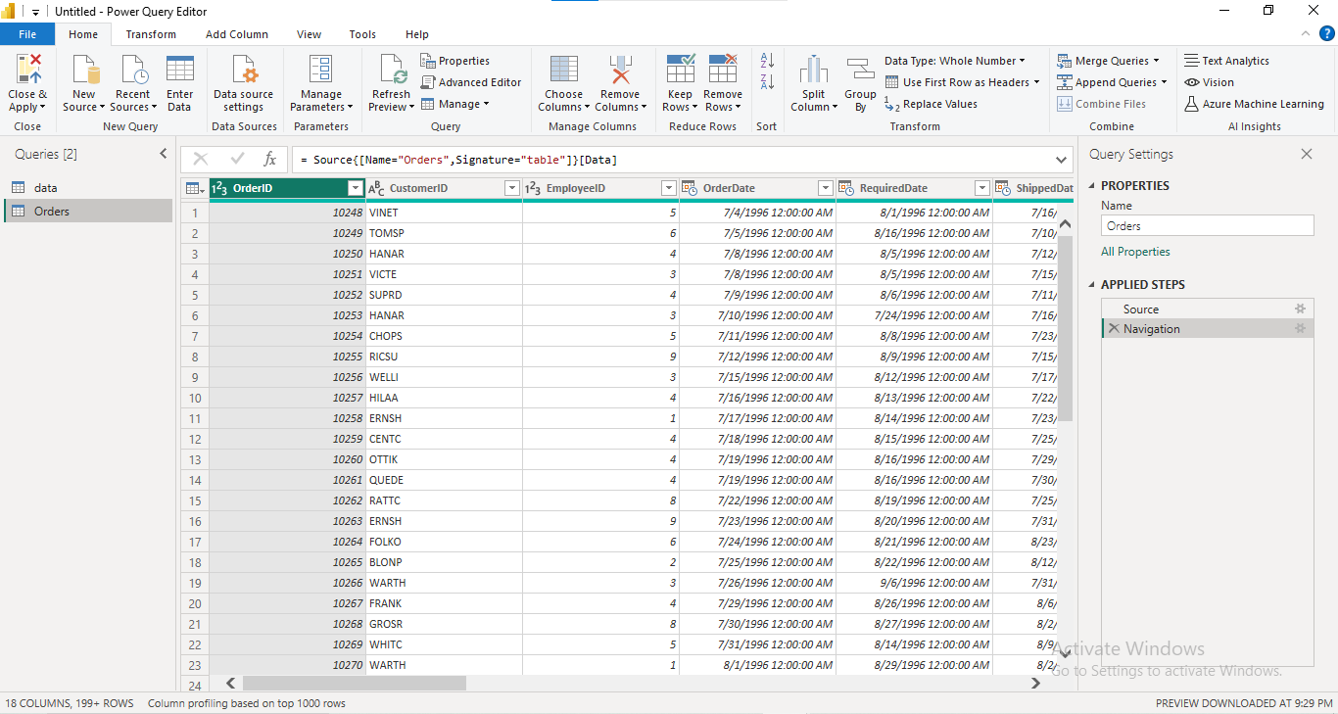

**Name: Yash Laxman Gawade**

**Roll No.: 21140 Subject: CL-4**

**Class: BE (A) Branch: AI&DS**

**Assignment No.: 02**

**Output:**

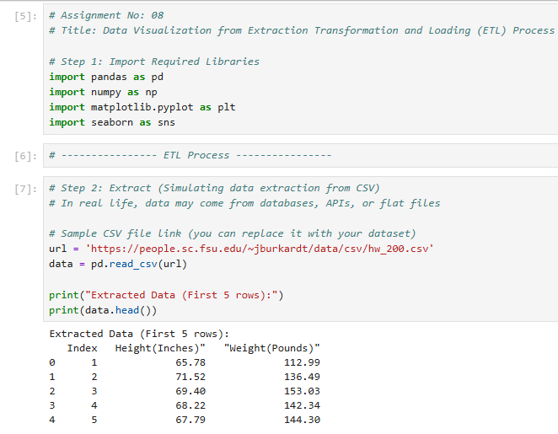

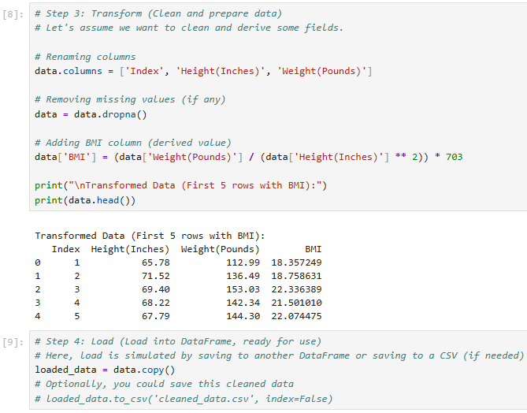

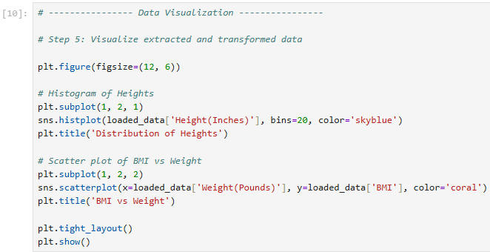

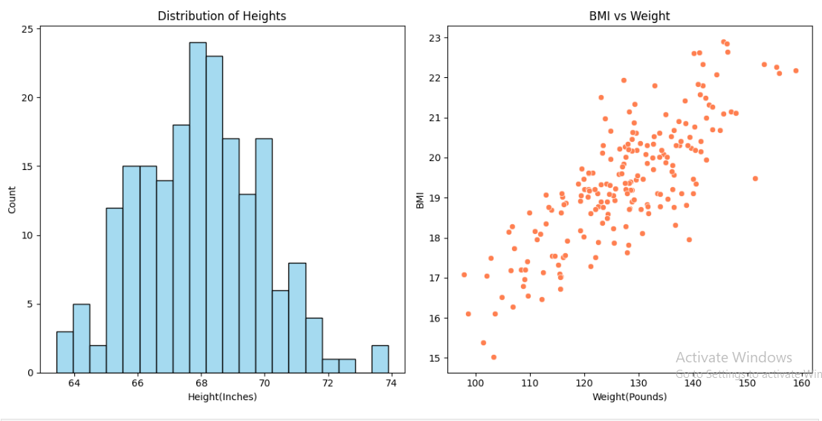

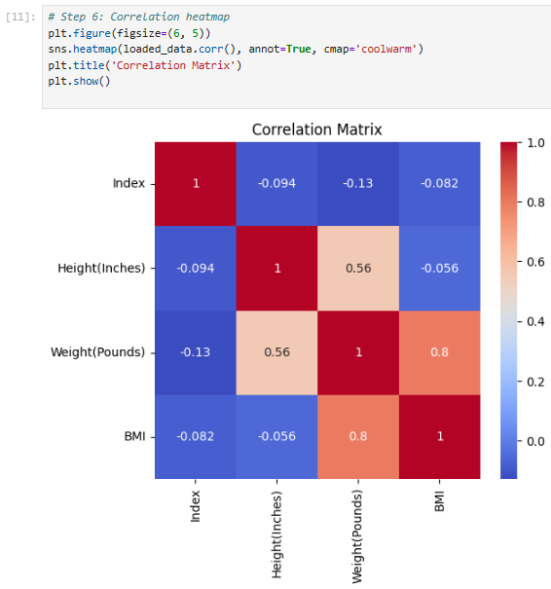

**Name: Yash Laxman Gawade**

**Roll No.: 21140 Subject: CL-4**

**Class: BE (A) Branch: AI&DS**

**Assignment No.: 03**

**Output:**

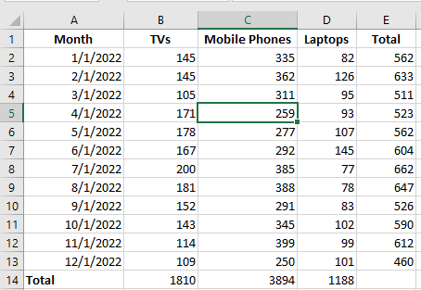

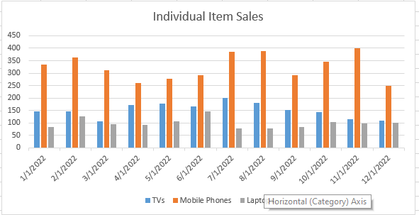

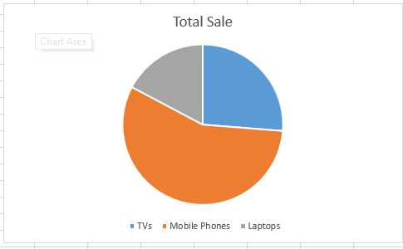

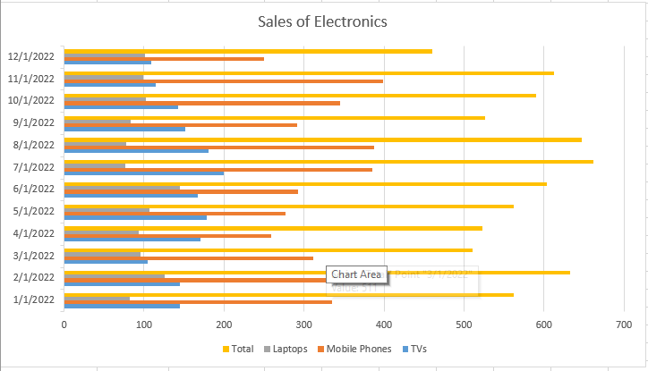

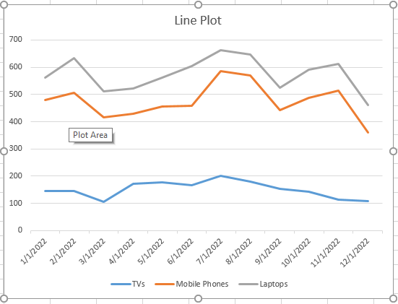

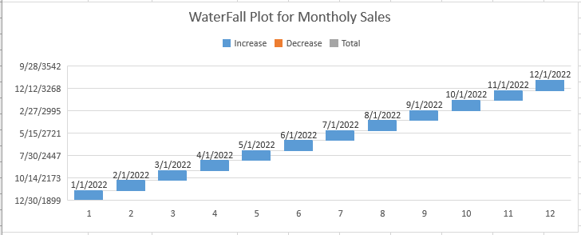

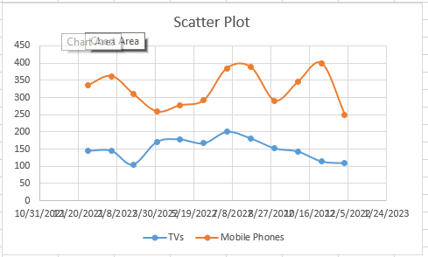

**Name: Yash Laxman Gawade**

**Roll No.: 21140 Subject: CL-3**

**Class: BE (A) Branch: AI&DS**

**Assignment No.:**

**Output:**

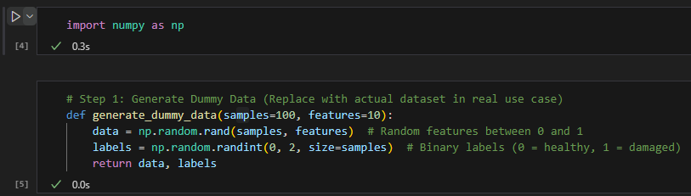

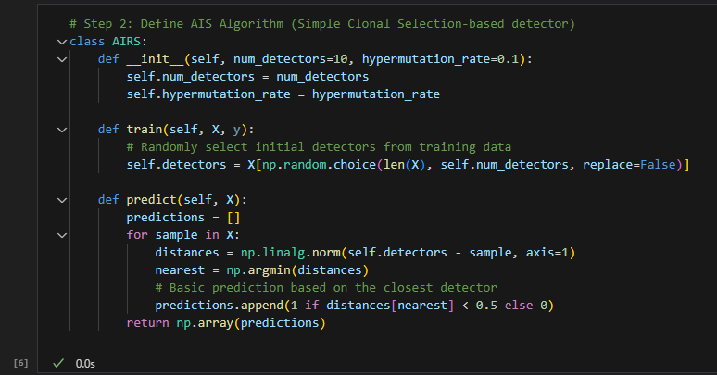

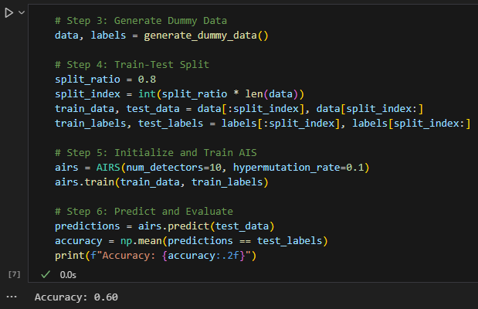

**Name: Yash Laxman Gawade**

**Roll No.: 21140 Subject: CL-3**

**Class: BE (A) Branch : AI&DS**

**Assignment No.:**

**Output:**

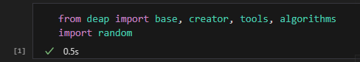

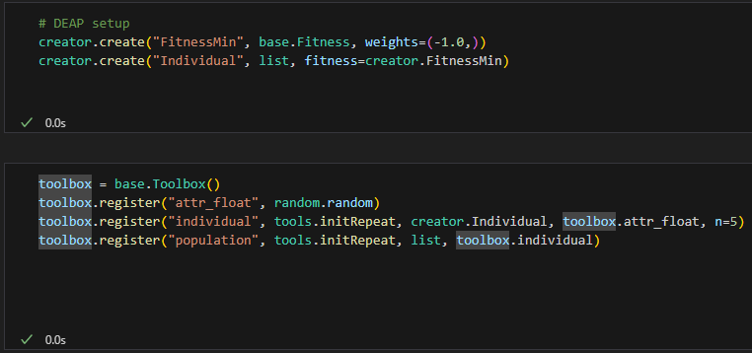



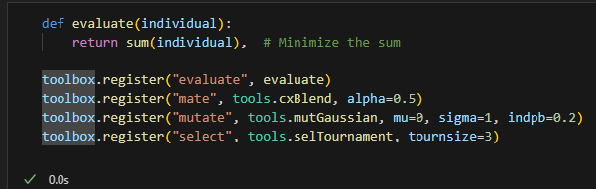

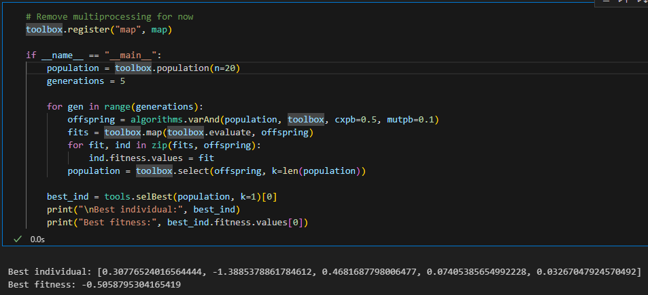

**Name: Yash Laxman Gawade**

**Roll No.: 21140 Subject: CL-4**

**Class: BE (A) Branch : AI&DS**

**Assignment No.:**

**Output:**

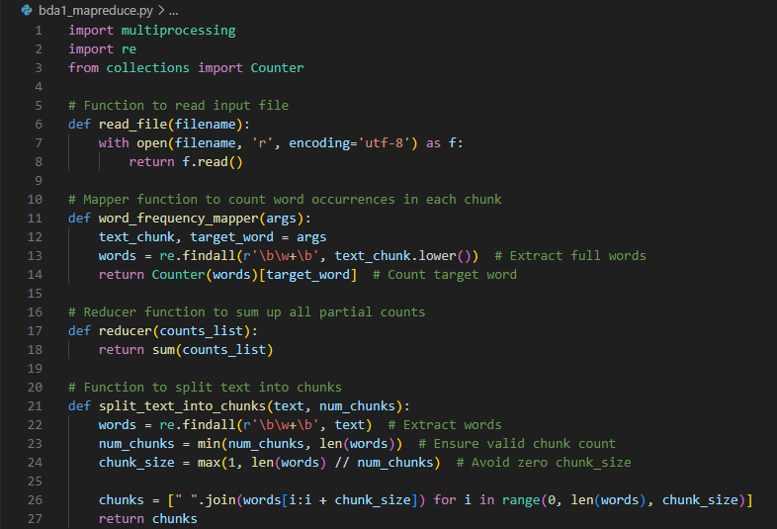

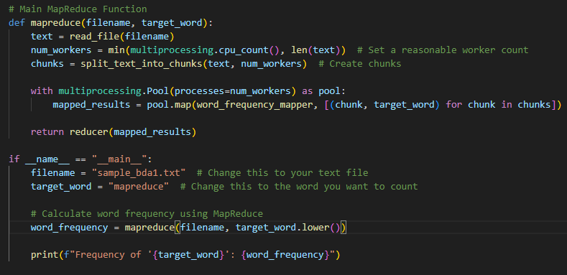



**Name: Yash Laxman Gawade**

**Roll No.: 21140 Subject: CL-4**

**Class: BE (A) Branch : AI&DS**

**Assignment No.:**

**Output:**

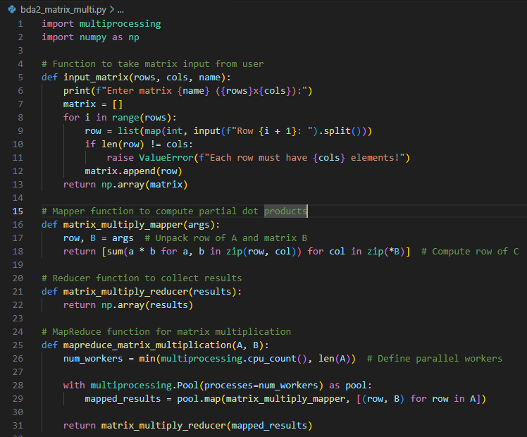

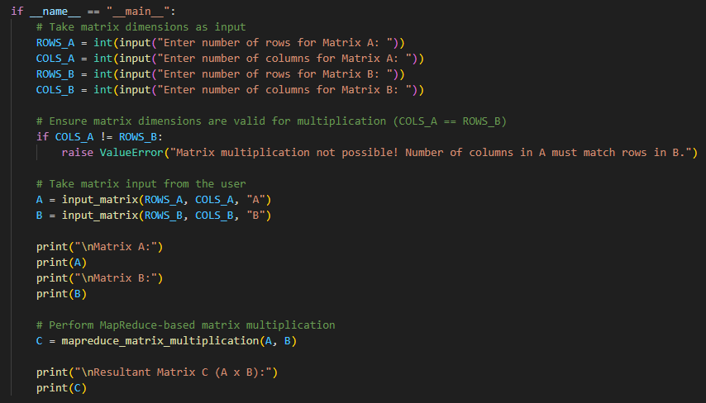

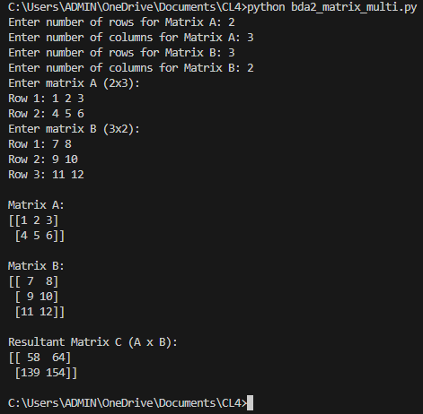

**Name: Yash Laxman Gawade**

**Roll No.: 21140 Subject: CL-4**

**Class: BE (A) Branch : AI&DS**

**Assignment No.:**

**Output:**

